University Laboratory Management Server
A Project Report Submitted in the partial fulfillment of the requirements for the award of the degree of

BACHELOR OF TECHNOLOGY
In

DEPARTMENT OF COMPUTER SCIENCE ENGINNERING

By

B JHAHNAVI 2520030452

P MOUVYA SRI 2520030449

Under the Esteemed Guidance of

Dr. Y. Harika Devi
Assistant Professor
Department of Computer Science and Engineering




K L (Deemed to be) University DEPARTMENT OF COMPUTER SCIENCE ENGINEERING
&

DEPARTMENT OF COMPUTER SCIENCE AND INFORMATION TECHNOL

Declaration

The Project Report entitled “University Laboratory Management Server “ is a record of Bonafide work of submitted in B. Jhahnavi — 2520030452,P. Mouvya Sri — 2520030449 partial fulfillment for the award of B. Tech in Computer Science and Engineering (or) Computer Science and Information Technology to the K L University. The results embodied in this report have not been copied from any other departments/University/Institute.

B JHAHNAVI 2520030452

P MOUVYA SRI 2520030449

K L (Deemed to be) University

DEPARTMENT OF COMPUTER SCIENCE ENGINEERING

CERTIFICATE

This is certify that the mini project based report entitled“University Laboratory Management Server” is a bonafide work done and submitted by B. Jhahnavi (2520030452) and P. Mouvya Sri (2520030449 ) in partial fulfillment of the requirements for the award of the degree of BACHELOR OF TECHNOLOGY in Department of Computer Science Engineering, K L (Deemed to be University), during the academic year 2024-2025.

Signature of the Guide

Signature of the Course Coordinator Signature of the HOD

ACKNOWLEDGEMENT
The success in this project would not have been possible but for the timely help and guidance rendered by many people. Our wish to express my sincere thanks to all those who has assisted us in one way or the other for the completion of my project.

Our greatest appreciation to my Course Coordinator , and my guide Dr. Y. Harika Devi Department of Computer Science which cannot be expressed in words for his/her tremendous support, encouragement and guidance for this project.

We express our gratitude to Dr. P Venkateshwara Roa (CSE), Head of the Department for Computer Science Engineering for providing us with adequate facilities, ways and means by which we are able to complete this project-based Lab.

We thank all the members of teaching and non-teaching staff members, and also who have assisted me directly or indirectly for successful completion of this project. Finally, I sincerely thank my parents, friends and classmates for their kind help and cooperation during my work.

B JHAHNAVI 2520030452

P MOUVYA SRI 2520030449
Abstract

The University Laboratory Management Server is a C-based application developed in a Linux/Ubuntu environment to organize university laboratory information. Managing student records, faculty details, laboratory information, equipment records, and equipment bookings manually can be time-consuming and difficult to maintain consistently. This project provides a menu-driven application that simplifies these operations through a structured record-management system.

The application consists of separate modules for students, faculty, laboratories, equipment, and equipment bookings. It allows users to add and view records through a terminal-based interface. The records are stored in text files, enabling the information to remain available between program executions.

In addition to record management, the project demonstrates important Operating Systems concepts. System calls are used to write a message to a log file. Process management is demonstrated using fork() and wait(). Inter-process communication is demonstrated using an anonymous pipe that transfers information between a parent and child process. Memory management is illustrated using dynamic memory allocation functions such as malloc() and free(), along with memory mapping through mmap() and munmap().

The application is organized into multiple C source and header files and uses GCC and a Makefile for compilation. The project provides practical experience in modular programming, file handling, Linux APIs, process creation, IPC, and memory management. Future improvements could include stronger input validation, booking-conflict checks, authentication, and integration with a web-based interface.

Keywords: C Programming, Linux, Ubuntu, Laboratory Management, File Handling, System Calls, Process Management, IPC, Memory Management.

Index

S. No. | Chapter | Topics / Subtopics | Page No.
 | Acknowledgement |  | i
 | Abstract |  | ii
1 | Introduction |  | 1–5
 |  | 1.1 Background of the Project
 |  | 1.2 Problem Statement
 |  | 1.3 Scope of the Project
 |  | 1.4 Objectives of the Project
 |  | 1.5 Importance of the Application
 |  | 1.6 Target Users / Audience
2 | OS Concepts and Background Study |  | 6–12
 |  | 2.1 Operating System Concepts Related to the Project
 |  | 2.2 Existing Methods / Algorithms
 |  | 2.3 Proposed Approach
 |  | 2.4 Advantages of the Proposed Approach
3 | System Requirements |  | 13–17
 |  | 3.1 Hardware Requirements
 |  | 3.2 Software Requirements
 |  | 3.3 Operating System Environment – Ubuntu / WSL
 |  | 3.4 Development Tools and Compilers
4 | Technology and Tools Used |  | 18–22
 |  | 4.1 C / C++ Programming
 |  | 4.2 GCC Compiler
 |  | 4.3 Linux System Calls
 |  | 4.4 POSIX Threads / Synchronization
 |  | 4.5 Linux Commands and Utilities
 |  | 4.6 Other Tools / Libraries Used
5 | System Architecture and Design |  | 23–29
 |  | 5.1 Overall System Architecture
 |  | 5.2System Workflow
 |  | 5.3 Flowchart / Data Flow
 |  | 5.4 Module Description
 |  | 5.5 Input and Output Design
6 | Implementation |  | 30–45
 |  | 6.1 Module-wise Implementation
 |  | 6.2 Algorithm / Pseudocode
 |  | 6.3 Core C / C++ Implementation
 |  | 6.4 Linux System Calls / APIs Used
 |  | 6.5 Process / Thread Implementation
 |  | 6.6 IPC / Synchronization Implementation
 |  | 6.7 Memory Management Implementation
 |  | 6.8 Optional User Interface Implementation
7 | Execution and Demonstration |  | 62–67
 |  | 7.1 Compilation in Ubuntu
 |  | 7.2 Execution Commands
 |  | 7.3 Sample Inputs and Outputs
 |  | 7.4 Screenshots of Execution
 |  | 7.5 Demonstration of OS Concepts
8 | Conclusion |  | 79–83
 |  | 8.1 Summary of the Project
 |  | 8.2 Objectives Achieved
 |  | 8.3 Results Achieved
 |  | 8.4 Skills and Learning Outcomes
9 | References |  | 84–86
 |  | 9.1 Books
 |  | 9.2 Research Papers
 |  | 9.3 Linux / GNU Documentation
 |  | 9.4 Online Resources

CHAPTER -1 INTRODUCTION

Background of the Project

University laboratories contain various resources, including computers, scientific equipment, and other facilities used by students and faculty members.

Maintaining laboratory information manually can create difficulties in updating records, locating equipment details, and organizing booking information. A computer-based system can make these tasks easier by storing information in an organized format.

The University Laboratory Management Server project is developed using the C programming language in a Linux/Ubuntu environment. It provides a menu-driven interface for managing student records, faculty records, laboratory details, equipment information, and equipment bookings.

The project also incorporates Operating Systems concepts such as system calls, process management, inter-process communication, and memory management. These features help demonstrate how operating-system facilities can be used in a practical application.

1.2 Problem Statement

Manual management of university laboratory information can lead to difficulties in maintaining records of students, faculty members, laboratories, equipment, and bookings.

Separate registers and unorganized records can make information difficult to retrieve and update. There is a need for a simple computer-based application that organizes these records and demonstrates fundamental operating-system concepts.

The proposed project addresses this problem through a modular C application that stores laboratory-related information in text files and provides menu options to add and view records.

1.3 Scope of the project

The scope of the project includes:

Adding and viewing student records.

Adding and viewing faculty records.

Adding and viewing laboratory details.

Adding and viewing equipment information.

Recording equipment bookings.

Viewing booking records.

Displaying a basic report summary.

Demonstrating system calls and file operations.

Demonstrating process creation and synchronization.

Demonstrating pipe-based inter-process communication.

Demonstrating dynamic memory allocation and memory mapping.

The current implementation uses a command-line interface. Advanced features such as a networked multi-client server, authentication, automatic booking-conflict detection, and web-interface integration are not established by the supplied C source code.

1.4 Objectives of the Project

The main objectives are:

To develop a modular laboratory-management application using C.

To maintain student and faculty records.

To manage laboratory and equipment information.

To record and display equipment bookings.

To store records in text files using file-handling functions.

To demonstrate Linux system calls.

To understand process creation and parent-child synchronization.

To implement inter-process communication using pipes.

To demonstrate dynamic memory allocation and memory mapping.

To compile and execute the application using GCC and Make in Ubuntu.

1.5 Importance of the Application

The application provides a simple and organized way to maintain laboratory-related records.

Its modular design separates different categories of information, making the source code easier to understand and maintain. Text-file storage allows records to be retrieved during later executions, provided the files remain available.

From an academic perspective, the project demonstrates the application of Operating Systems concepts in a practical C programming project.

1.6 Target Users / Audience

The intended users and audience include:

Laboratory assistants responsible for maintaining equipment records.

Faculty members who need organized laboratory information.

Students who need to understand laboratory record-management concepts.

Computer Science students learning C programming and Operating Systems.

Faculty members evaluating systems-programming concepts.

CHAPTER -2 SYSTEM REQUIREMENTS

2.1 Operating System Concepts Related to the Project

The project demonstrates several fundamental concepts of an operating system.

System Calls

A system call allows a program to request a service from the operating system.

In this project, the system-call demonstration uses:

open() to open the system log file.

write() to write a message into the file.

close() to release the file descriptor.

The message is appended to logs/system.log.

These functions demonstrate how a C program interacts with Linux file services.

B. Process Management

A process is a program in execution.

The project demonstrates process creation using fork().

When fork() executes, the operating system creates a child process. The child prints its process ID and terminates. The parent uses wait(NULL) to wait for the child process to finish.

The implementation demonstrates:

Process creation.

Parent and child processes.

Process identification using getpid().

Parent-child synchronization using wait().

C. Inter-Process Communication

Inter-process communication, or IPC, allows processes to exchange information.

The project uses an anonymous pipe for IPC.

The pipe has two ends:

pipefd[0] — the read end.

pipefd[1] — the write end.

The parent process writes the message:

Laboratory equipment booking information

The child process reads the message from the pipe and displays it.

This demonstrates communication between related processes.

D. Memory Management

Memory management involves allocating, accessing, and releasing memory.

The project demonstrates two techniques.

Dynamic memory allocation: The program uses malloc() to allocate memory for five integers and free() to release the allocated memory.

The values stored are:

10, 20, 30, 40, 50

Memory mapping: The program uses mmap() to map a memory region, stores the value 100, and releases the region using munmap().

The mapping uses private anonymous memory. It is a memory-mapping demonstration, not an implementation of shared memory between processes.

E. File Handling

File handling is used to store and retrieve records.

The program uses functions such as:

fopen() to open files.

fprintf() to write formatted records.

fgets() to read records line by line.

fclose() to close files.

Each category of information is stored in a separate text file.

2.2 Existing Methods / Algorithms

In a manual laboratory-management process, information may be maintained in paper registers or separate files.

This can make it difficult to update records consistently, retrieve information quickly, and organize booking details.

The proposed application provides a menu-based method for maintaining the records and uses separate text files for different categories of information.

2.3 Proposed Approach

The proposed system is a modular, menu-driven C application.

The main program displays a menu and accepts the user's choice. Based on that choice, the program calls the appropriate function.

For example:

addStudent() adds a student record.

viewStudents() displays student records.

addFaculty() adds faculty information.

addLaboratory() adds laboratory information.

addEquipment() adds equipment information.

bookEquipment() records a booking.

The application also runs operating-system demonstrations during initialization.

2.4 Advantages of the Proposed Approach

Provides a simple terminal-based interface.

Organizes records into separate categories.

Stores information in text files.

Uses modular C programming.

Demonstrates Linux system calls.

Demonstrates process management and IPC.

Demonstrates memory allocation and memory mapping.

Uses a Makefile to simplify compilation.

CHAPTER 3 — SYSTEM REQUIREMENTS

3.1 Hardware Requirements
Component | Suggested requirement
Computer | Laptop or desktop
Processor | Modern dual-core processor or better
RAM | 4 GB or more recommended
Storage | Sufficient space for Ubuntu, source files, and records
Keyboard | For entering menu choices and record information
Display | For viewing program output

3.2 Software Requirements

Software | Purpose
Ubuntu/Linux | Operating environment
GCC | Compiles the C source files
GNU Make | Automates the build process
Terminal | Runs commands and the application

3.3 Operating System Environment — Ubuntu

The application is designed to run in a Linux/Ubuntu environment.

Linux provides the system interfaces required for process creation, IPC, file operations, and memory management.

The program uses relative paths for its data and log files. Therefore, it should be executed from the project directory containing the data/ and logs/ folders.

3.4 Development Tools and Compilers

The project uses GCC as its C compiler.

The Makefile contains the following configuration:

CC = gcc

CFLAGS = -Wall -Wextra

TARGET = university_lab

The Makefile compiles the source files into object files and links them to create the executable named university_lab.

The make clean command removes generated object files and the executable.

CHAPTER 4 — TECHNOLOGY AND TOOLS USED

4.1 C Programming

C is a procedural programming language commonly used for systems programming.

In this project, C is used to implement the menu, record-management functions, file operations, and operating-system demonstrations.

The application is divided into source files and header files, which makes the program easier to organize.

4.2 GCC Compiler

GCC is used to compile the C source files.

The project Makefile specifies -Wall and -Wextra to enable additional compiler warnings.

The source files are compiled separately and linked into the final executable.

4.3 Linux System Calls and APIs Used

Function | Purpose in the project
open() | Opens the system log file
write() | Writes a log message and sends data through the pipe
close() | Closes file descriptors
fork() | Creates child processes
getpid() | Retrieves the current process ID
wait() | Waits for a child process to finish
pipe() | Creates an IPC channel
read() | Reads a message from the pipe
malloc() | Allocates dynamic memory
free() | Releases dynamically allocated memory
mmap() | Maps a memory region
munmap() | Releases a mapped memory region

4.4 Threads and Synchronization

The supplied source code demonstrates process-based concurrency using fork() and parent-child synchronization using wait().

It does not show the creation of POSIX threads using pthread_create() or the use of mutexes.

Therefore, the implementation chapter should describe process management and synchronization through wait() rather than claiming that multithreading has been implemented.

4.5 Linux Commands and Utilities

Command | Purpose
pwd | Displays the current directory
ls | Lists files and directories
cd | Changes the current directory
make | Compiles the project
make clean | Removes generated object files and executable
make run | Builds and executes the application
./university_lab | Runs the compiled application
man 2 fork | Opens the manual page for fork()

4.6 Other Tools / Libraries Used

The project uses the standard C library and Linux/POSIX interfaces.

The Makefile automates the build process. Text files in the data/ directory store application records, and logs/system.log stores the system-call demonstration message.

Mention Git or GitHub in the final report only if your team actually used them.

CHAPTER 5 — SYSTEM ARCHITECTURE AND DESIGN

5.1 Overall System Architecture

The system consists of a main menu, record-management modules, text-file storage, and an operating-system demonstration module.

The main.c file controls the menu and calls the relevant functions.

The system has the following components:
Component | Responsibility
main.c | Displays the menu and handles user choices
Student module | Adds and displays student records
Faculty module | Adds and displays faculty records
Laboratory module | Adds and displays laboratory records
Equipment module | Adds and displays equipment records
Booking module | Records and displays equipment bookings
OS features module | Demonstrates system calls, processes, IPC, and memory management
data/ directory | Stores application records
logs/system.log | Stores the system-call demonstration message
Makefile | Automates compilation and execution

5.2 System Workflow

The system follows these steps:

The user starts the application from the Ubuntu terminal.

The program initializes the operating-system demonstrations.

The main menu is displayed.

The user selects an operation.

The main program calls the corresponding function.

The function collects input or reads existing records.

Data is appended to the appropriate text file when required.

The program displays the result.

The menu is displayed again.

The user selects Exit to terminate the program.

5.3 Flowchart / Data Flow

Use this sequence to draw your flowchart:

START → Initialize OS demonstrations → Display menu → Read choice → Call selected module → Read/write data file → Display result → Return to menu → Exit

In your Word document, draw a flowchart with:

An oval for Start and Stop.

A rectangle for initialization.

A parallelogram for input/output.

A decision diamond for the menu choice.

A loop returning to the main menu.

5.4 Module Description

Module | Description
Student module | Adds student ID, name, department, and year; displays stored student records
Faculty module | Adds faculty ID, name, and department; displays stored faculty records
Laboratory module | Adds laboratory ID, name, department, and capacity; displays laboratory records
Equipment module | Adds equipment ID, name, quantity, and status; displays equipment records
Booking module | Records student ID, equipment ID, booking date, and booking status
Reports module | Prints the categories included in the basic report summary
OS features module | Demonstrates system calls, process creation, pipe-based IPC, and memory management

5.5 Input and Output Design

The application receives input through the terminal using scanf().

The input depends on the selected menu option.

For example, when adding a student, the application accepts:

Student ID.

Student name.

Department.

Year.

The information is stored in data/students.txt.

Similarly, equipment information is stored in data/equipment.txt, and booking information is stored in data/bookings.txt.

The view functions display the stored records on the terminal.
Menu option | Operation | File
1 / 2 | Add / view students | data/students.txt
3 / 4 | Add / view faculty | data/faculty.txt
5 / 6 | Add / view laboratories | data/laboratories.txt
7 / 8 | Add / view equipment | data/equipment.txt
9 / 10 | Book / view equipment bookings | data/bookings.txt
11 | Generate report summary | Terminal output
12 | Exit | —

CHAPTER 6 — IMPLEMENTATION

6.1 Module-wise Implementation

The application is divided into multiple C source files.

The main file, main.c, includes the required header files and displays the menu. A switch statement calls the appropriate function according to the user's selection.

Each record-management module performs a specific operation.

Student Module

The addStudent() function accepts student information and appends it to data/students.txt.

The viewStudents() function reads the file line by line and displays the stored records.

Faculty Module

The addFaculty() function stores faculty ID, name, and department.

The viewFaculty() function displays the existing faculty records.

Laboratory Module

The addLaboratory() function accepts laboratory ID, name, department, and capacity.

The viewLaboratories() function displays the stored laboratory records.

Equipment Module

The addEquipment() function accepts equipment ID, name, quantity, and status.

The viewEquipment() function displays the equipment records.

Booking Module

The bookEquipment() function accepts a student ID, equipment ID, and booking date. It appends the booking details to data/bookings.txt, together with the status BOOKED.

The viewBookings() function displays stored booking records.

The current booking function records a booking but does not check whether the student or equipment exists or whether the requested booking conflicts with another booking.

6.2 Algorithm / Pseudocode

Main program algorithm

START

Initialize system-call demonstration

Demonstrate process management

Demonstrate IPC using a pipe

Demonstrate memory management

REPEAT

Display main menu

Read user's choice

IF choice = 1

Add student

ELSE IF choice = 2

View students

ELSE IF choice = 3

Add faculty

ELSE IF choice = 4

View faculty

ELSE IF choice = 5

Add laboratory

ELSE IF choice = 6

View laboratories

ELSE IF choice = 7

Add equipment

ELSE IF choice = 8

View equipment

ELSE IF choice = 9

Book equipment

ELSE IF choice = 10

View bookings

ELSE IF choice = 11

Generate report summary

ELSE IF choice = 12

Exit

ELSE

Display invalid choice message

END IF

UNTIL the user exits

STOP

6.3 Core C Implementation

The application uses modular programming to separate the menu, record operations, and operating-system demonstrations.

For example, the student module uses fopen() to open the student data file in append mode. It collects the required fields and uses fprintf() to write them to the file.

The view function opens the same file in read mode and uses fgets() to display each record.

The operating-system module demonstrates:

Low-level file operations.

Process creation using fork().

Process synchronization using wait().

IPC using pipe().

Dynamic memory allocation using malloc() and free().

Memory mapping using mmap() and munmap().

The source files themselves can be included in an appendix if your university requires the complete implementation.

6.4 Linux System Calls / APIs Used

The project demonstrates the following system interfaces:

open(), write(), and close()

These functions are used to open the system log file, append a message, and close the file descriptor.

fork()

This function creates a child process. The parent and child follow different execution paths depending on the returned value.

wait()

The parent process uses wait(NULL) to wait for the child process to finish.

pipe()

This function creates the pipe used to transfer a message between the parent and child processes.

read() and write()

These functions read and write the message transferred through the pipe.

malloc() and free()

These functions demonstrate dynamic memory allocation and deallocation.

mmap() and munmap()

These functions demonstrate mapping and releasing a memory region.

6.5 Process / Thread Implementation

The project demonstrates process management through two uses of fork().

In the first demonstration, the child process prints its process ID and exits. The parent process waits for the child to complete.

In the second demonstration, a pipe is created before the child process is created. The parent sends a message through the pipe, and the child reads and displays it.

This demonstrates parent-child process creation and coordination.

The current source code does not implement POSIX threads.

6.6 IPC / Synchronization Implementation

The application demonstrates IPC using an anonymous pipe.

The pipe is created using:

pipe(pipefd);

The first array element, pipefd[0], is used for reading. The second element, pipefd[1], is used for writing.

The parent process writes a message into the pipe. The child process reads the message and displays it.

The processes close the pipe ends they do not use and the parent waits for the child to finish.

This demonstrates one-way communication between related processes.

6.7 Memory Management Implementation

The project demonstrates dynamic memory allocation using malloc().

Memory is allocated for five integers. The program stores the values 10, 20, 30, 40, and 50, displays them, and releases the memory using free().

The project also demonstrates memory mapping using mmap(). A memory region large enough for one integer is mapped, the value 100 is stored in it, and the mapping is released using munmap().

These examples demonstrate memory allocation and cleanup.

6.8 User Interface Implementation

The current application provides a terminal-based user interface.

The main menu includes options to add and view students, faculty, laboratories, equipment, and bookings. It also includes a basic report-summary option and an exit option.

The application displays messages to indicate the result of supported operations.

A graphical or web-based interface can be considered a future improvement. Although a web/ directory is present in the supplied archive, the main C application does not demonstrate integration with that interface.

CHAPTER 7 — EXECUTION AND DEMONSTRATION

7.1 Compilation in Ubuntu

The application can be compiled using the Makefile supplied with the project.

Open the Ubuntu terminal and navigate to the directory containing the Makefile.

cd UniversityLabManagement

make

The Makefile compiles the source files and creates the executable named university_lab.

7.2 Execution Commands

Run the application using:

./university_lab

Alternatively, the Makefile provides:

make run

The application displays the operating-system demonstration messages and then shows the main menu.

Enter the corresponding menu number to perform an operation. Select option 12 to exit.

7.3 Sample Inputs and Outputs

Use actual inputs and terminal output from your demonstration in the final report.
Test | Input / action | Expected behaviour
Program startup | Run ./university_lab | Displays OS demonstration messages and the main menu
Add student | Choose option 1 and enter the requested fields | Appends a record to the student file
View students | Choose option 2 | Displays stored student records
Add equipment | Choose option 7 and enter equipment details | Appends a record to the equipment file
Book equipment | Choose option 9 and enter booking details | Appends a booking record
View bookings | Choose option 10 | Displays stored booking records
Exit | Choose option 12 | Displays a thank-you message and exits

Important: These describe the behaviour indicated by the source code. Run each test and record the actual result before marking it as passed.

7.4 Screenshots of Execution

Insert screenshots of your actual Ubuntu execution in this section.

Recommended screenshots:

Figure 7.1 — Program startup

the terminal after the program starts and displays the OS demonstration messages.

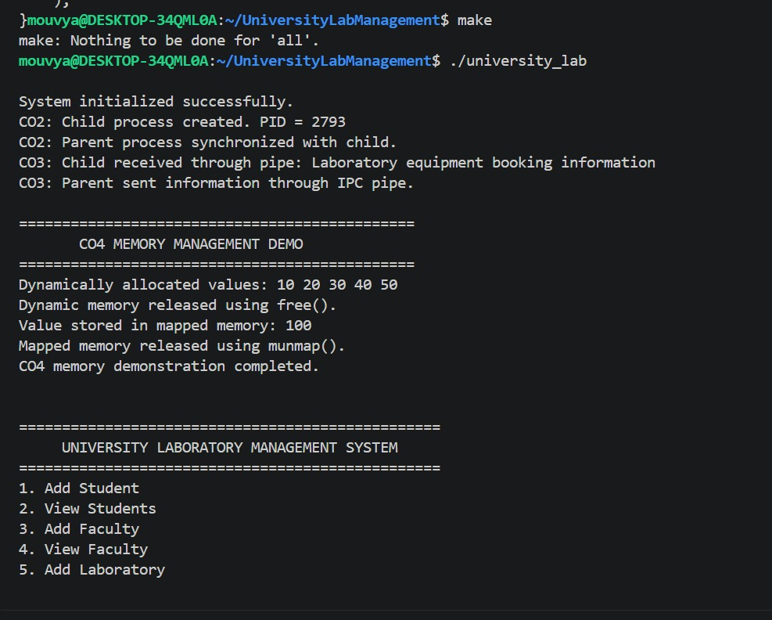

Figure 7.2 — Main menu

The laboratory-management menu with its twelve options.

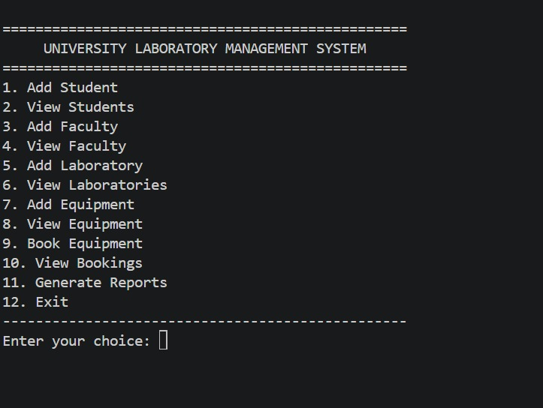

Figure 7.3 — Student or equipment management

a record being entered and subsequently displayed

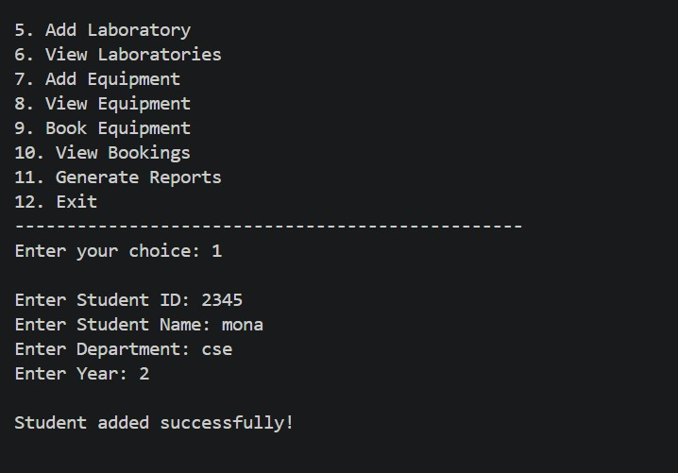

Figure 7.4 — Equipment booking

The booking process and the resulting booking record.

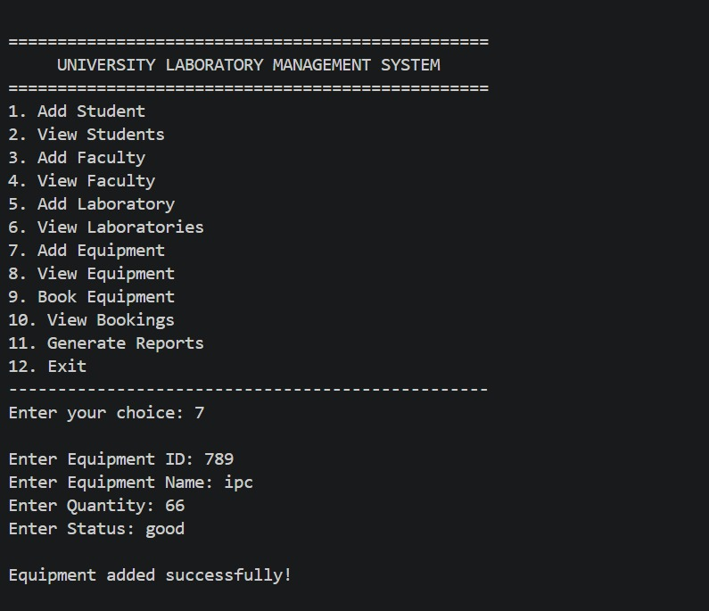

Figure 7.5 — System log

Show the contents of logs/system.log.

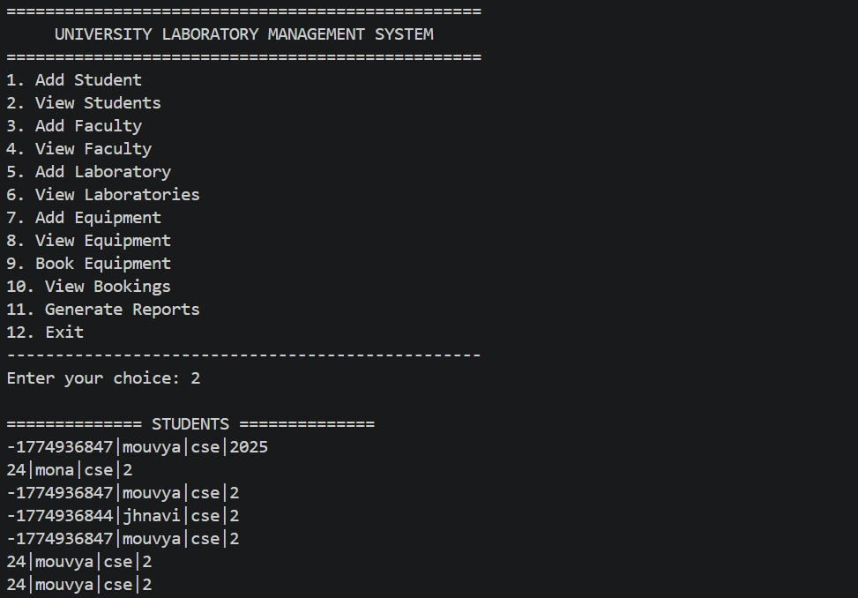

7.5 Demonstration of OS Concepts

Concept | Demonstration
System calls | Uses open(), write(), and close() to append a message to the log
Process management | Uses fork() to create a child process
Process synchronization | Uses wait() to wait for child-process completion
IPC | Uses pipe(), write(), and read() to transfer a message
Dynamic memory | Uses malloc() and free()
Memory mapping | Uses mmap() and munmap()
File handling | Uses fopen(), fprintf(), fgets(), and fclose()

CHAPTER 8 — CONCLUSION

8.1 Summary of the Project

The University Laboratory Management Server project is a modular C application developed in a Linux/Ubuntu environment.

The application provides functions for adding and viewing student records, faculty records, laboratory information, equipment details, and equipment bookings. It stores the information in text files and uses a menu-driven terminal interface.

The project also demonstrates important Operating Systems concepts, including system calls, process management, IPC through pipes, dynamic memory allocation, and memory mapping.

8.2 Objectives Achieved

The supplied implementation provides the following features:

Student record management.

Faculty record management.

Laboratory record management.

Equipment record management.

Equipment booking records.

File-based storage.

System-call demonstration.

Process creation and synchronization.

Pipe-based inter-process communication.

Dynamic memory allocation and memory mapping.

These features provide practical experience in C programming and Linux system programming.

8.3 Results Achieved

The source code provides a menu-driven application with separate modules for managing laboratory-related records.

The operating-system module demonstrates process creation, pipe-based communication, system-log writing, and memory-management operations.

The final report should include screenshots and test results from the actual Ubuntu execution.

The current implementation does not establish a networked multi-client socket server, authentication, automatic booking-conflict checking, or complete report-file generation. These are possible areas for further development.

8.4 Skills and Learning Outcomes

Through this project, we gained experience in:

Modular C programming.

Header files and function organization.

File handling and persistent text records.

Compilation and linking using GCC.

Build automation using Make.

Linux system calls.

Process creation and synchronization.

Inter-process communication using pipes.

Dynamic memory allocation.

Memory mapping.

Testing and documenting a software application.

Future Scope

The system can be improved in several ways:

Add input validation and better error handling.

Implement search, edit, and delete operations.

Validate student and equipment IDs before accepting bookings.

Check equipment availability and prevent conflicting bookings.

Add authentication and access control for different user roles.

Introduce a database for larger collections of records.

Integrate and test a web-based interface.

Add automated testing and more detailed reporting.

If required, develop a networked client-server version using sockets.

CHAPTER 9 — REFERENCES

9.1 Books

Abraham Silberschatz, Peter B. Galvin, and Greg Gagne, Operating System Concepts, Wiley.

Brian W. Kernighan and Dennis M. Ritchie, The C Programming Language, Prentice Hall.

W. Richard Stevens and Stephen A. Rago, Advanced Programming in the UNIX Environment, Addison-Wesley.

9.2 Linux / GNU Documentation

Linux manual pages for fork(), pipe(), wait(), mmap(), open(), read(), write(), and close().

GNU Compiler Collection documentation.

GNU Make manual.

9.3 Online Resources

Linux Manual Pages

GCC Documentation

GNU Make Manual

